Group buy kit assembly instructions

A work in progress

Introduction
Instructions presented in this document are related to Complete kit for EEZ H24005 power supply offered through crowdfunding campaign. If you intended to build one from the scratch e.g. having only bare PCBs to start with, please refer to EEZ PSU H24005 building instructions (r5B12).

The EEZ H24005 (PSU) kit is not an end user product. As such it was not put into any conformance testing and it may not comply with some or any technical or legal requirement that are applicable to finished products including, without limitation, directives regarding electromagnetic compatibility, recycling (WEEE), FCC, CE, or UL. Assembling and using the PSU requires an understanding of electronic circuits and basic computer programming skills.

If you need assistance, please contact us using this form or post your problem on the EEVblog forum here. Or, feel free to open a New issue on GitHub here, but please check first to see whether a similar issue already exists).

Only tool required for kit assembly is medium Phillips head screwdriver.

Kit assembly steps
- Package content
- Plastic bags content
- Bottom plate
- Rear panel
- AC/DC modules
- Front panel
- Power boards
- Final steps

Package content
The PSU complete kit consists of the following parts, as shown in Fig. 1:
- Top and bottom plates
- Front panel box
- Rear panel box
- Plastic bags with wire harness and miscellaneous mounting parts
- AC/DC modules box
- Power boards box
Rear panel box contains enclosure’s rear panel with mounted AUX power module, IEC AC inlet, 60 mm cooling fan with finger guard and Cable Set #2.
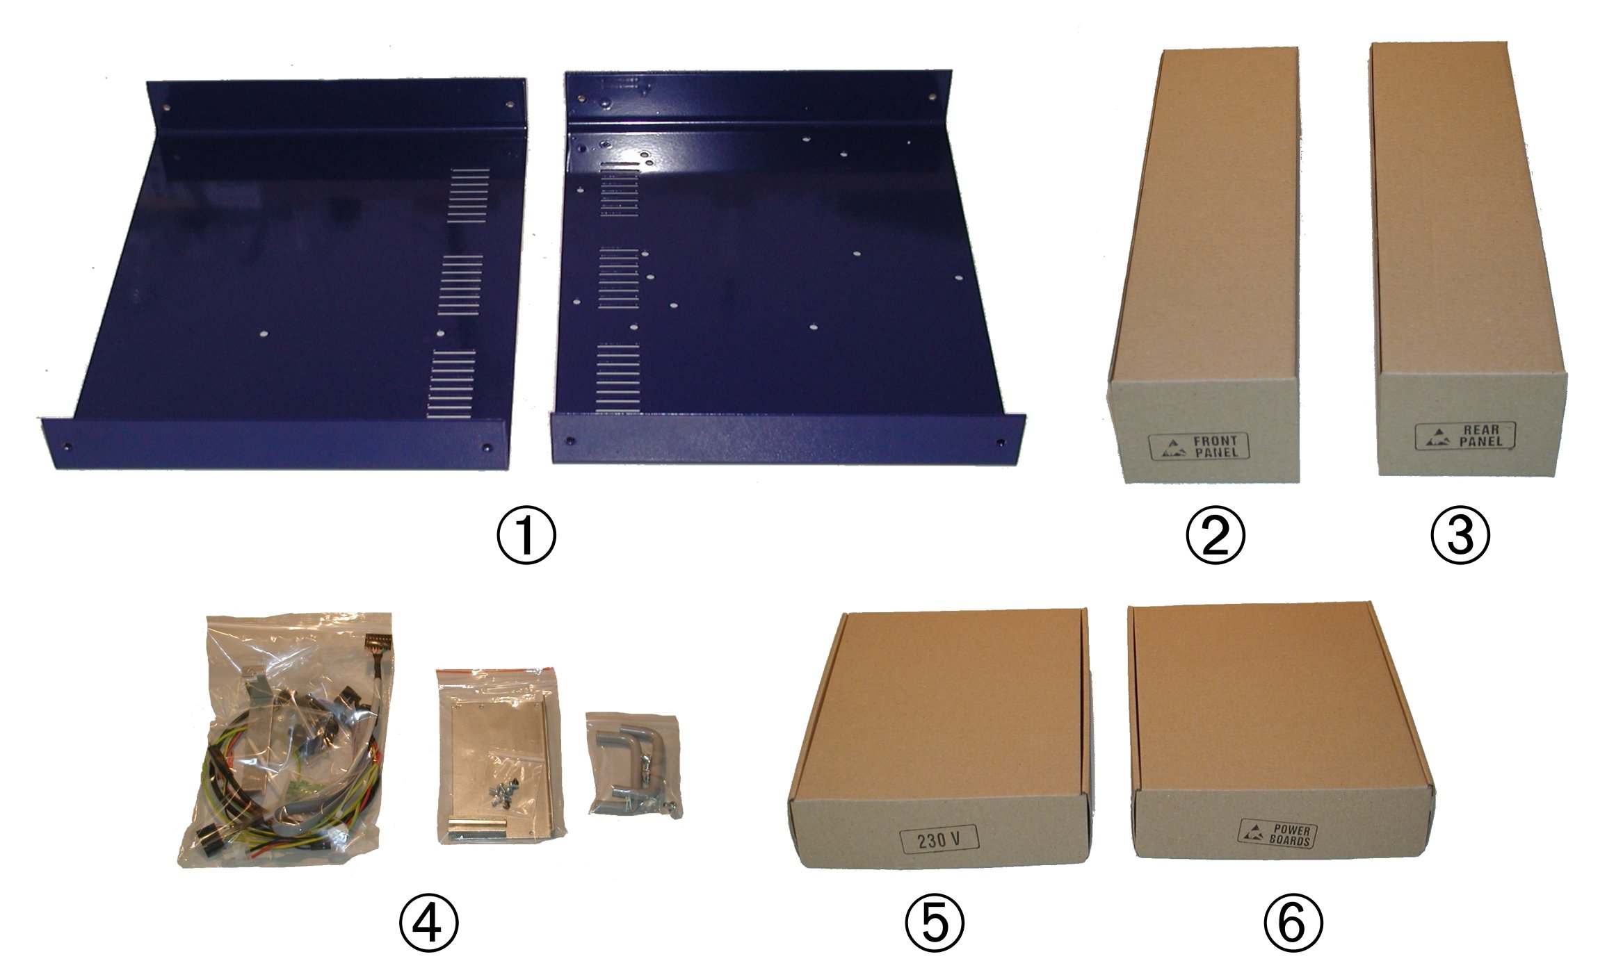Fig. 1: EEZ H24005 Complete kit box content

Plastic bags content
Before start assembling please take some time to check if content of plastic bags includes all what is listed below. Also familiarize with Position naming that will be used in the rest of the document.

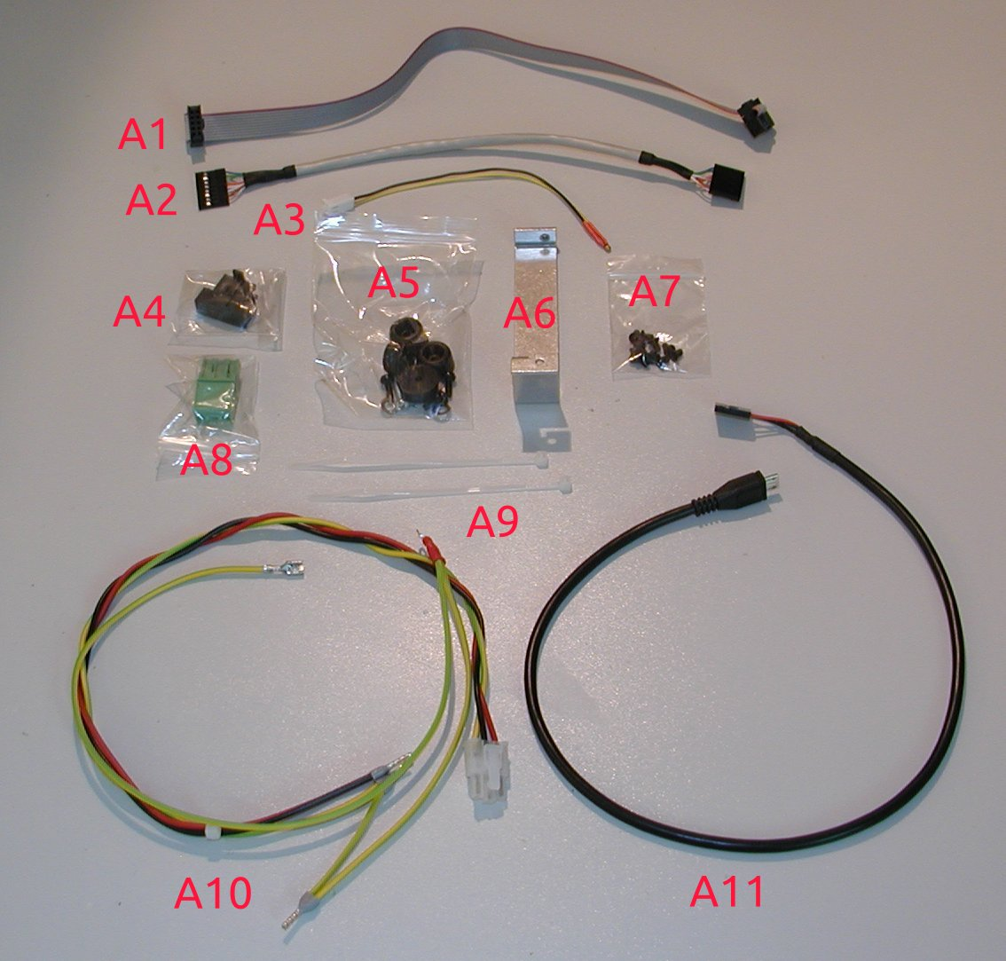Fig. 2: Plastic bag #1 content
Position | Description
A1 | 10-pin IDC cable (AUX power module – Arduino Shield)
A2 | Ethernet patch cable (AUX power module – Arduino Shield)
A3 | AUX temperature sensor (Arduino Shield)
A4 | Fuse drawer (IEC AC inlet)
A5 | Enclosure feet pack
A6 | AC&DC module connector cover
A7 | M3 x 5 mm bolts for enclosure (11 pcs)
A8 | DOUT2 plug-in connector (AUX power module)
A9 | Polyamide cable ties (2 pcs)
A10 | Cable set #1
A11 | Micro USB to 5-pin 0.1” header cable (AUX power module – Arduino Shield)

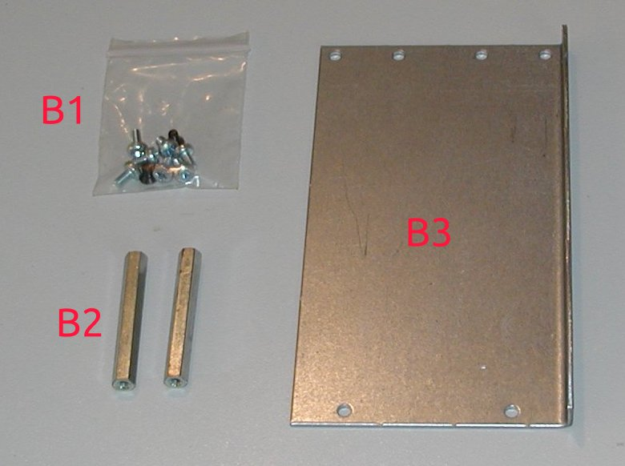Fig. 3: Plastic bag #2 content
Position | Description
B1 | AC/DC modules mounting bolts: M3 x 5 mm black countersunk head (2 pcs) and M3 x 5 mm (7 pcs)
B2 | 40 mm spacers (2 pcs)
B3 | AC/DC modules mounting rail (Varisom)

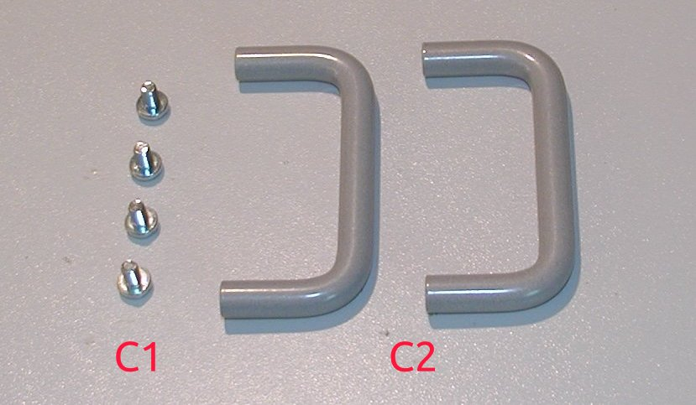Fig. 4: Plastic bag #3 content
Position | Description
C1 | M4 x 6 mm mounting bolts (4 pcs)
C2 | Enclosure front panel handles (Varisom)

Bottom plate
In this step rubber feet (D1, Fig. 6) will be mounted and protective earth will be attached to the enclosure. Identify enclosure bottom plate using the Fig. 5 and prepare items A5 and A10.

Content of A5 is shown on Fig. 6. Please note that longer bolt (D4) and additional parts (D5, D6) should be used for making contact with protective earth wire on the foot hole that is near the AC inlet (see note Foot (+Earth)).
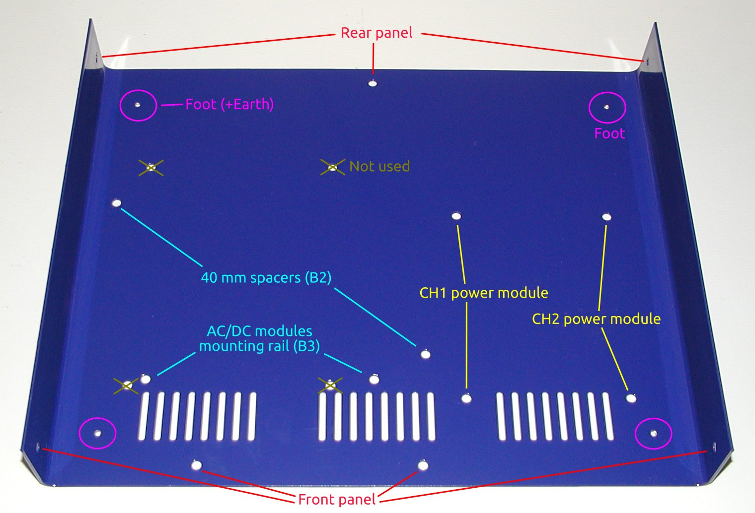Fig. 5: Enclosure bottom plate

Use M3 black finish bolt (D3) and washer (D2) for mounting feet (D1) on the holes with M3 thread (see red circled hole on Fig. 8). The paint around latest hole where protection earth will be connected can be previously carefully removed to ensure even better electrical contact then externally serrated washer (D5) could provide (see Fig. 7).
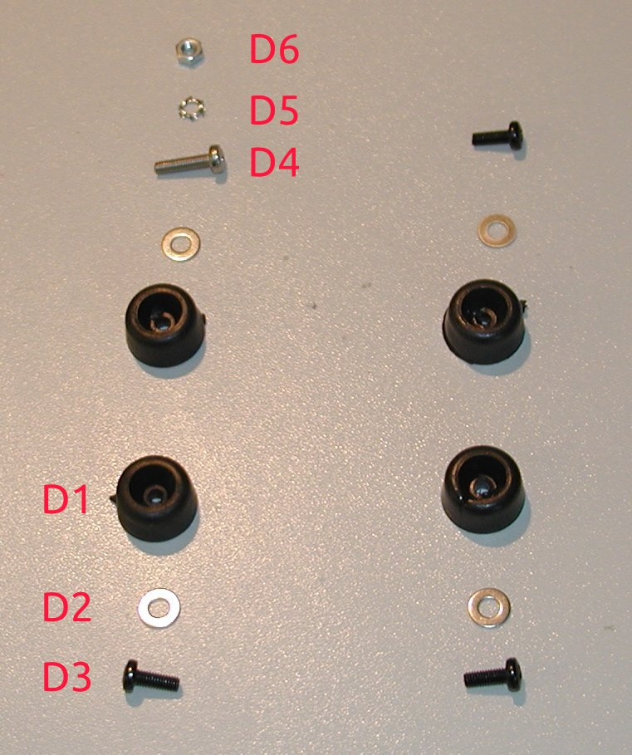Fig. 6: Enclosure feet package

For protective earth connection mount last foot with long bolt (D4) first and then place ring terminal (item A10) on inner (top) side of the bottom plate between serrated washer (D5) and M3 nut (D6). Check with ohmmeter if low resistance connection is established between earth wire on A10 and bottom plate (when complete enclosure is assembled you can repeat this by testing conductance between earth pin on IEC AC inlet and top plate).
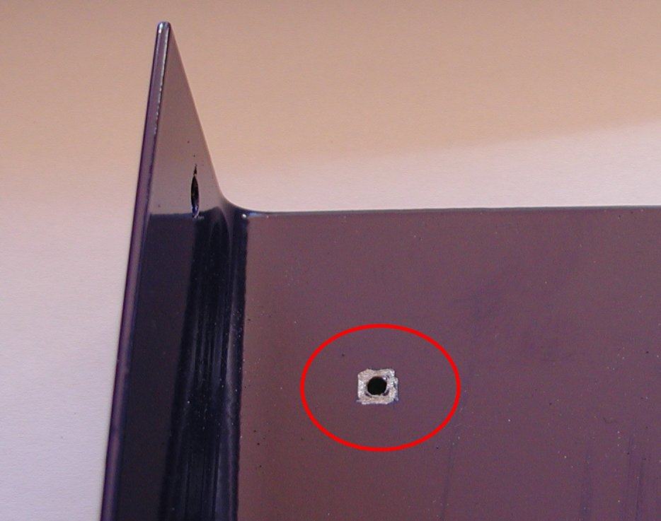Fig. 7: Paint removed for better protective earth contact
Fig. 8 shows bottom plate with protective earth mounted and Fig. 9 how robber foot looks like when mounted. Take into account that bolt should be screwed enough that its head is not above foot.

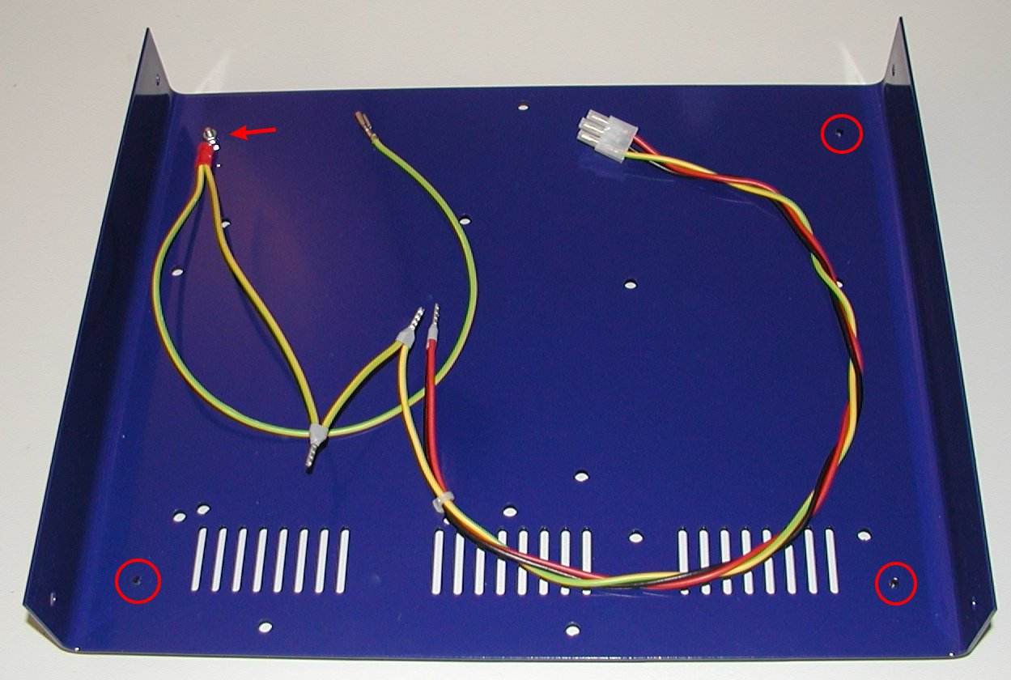Fig. 8: Bottom plate with mounted feet and protective earth

Rear panel
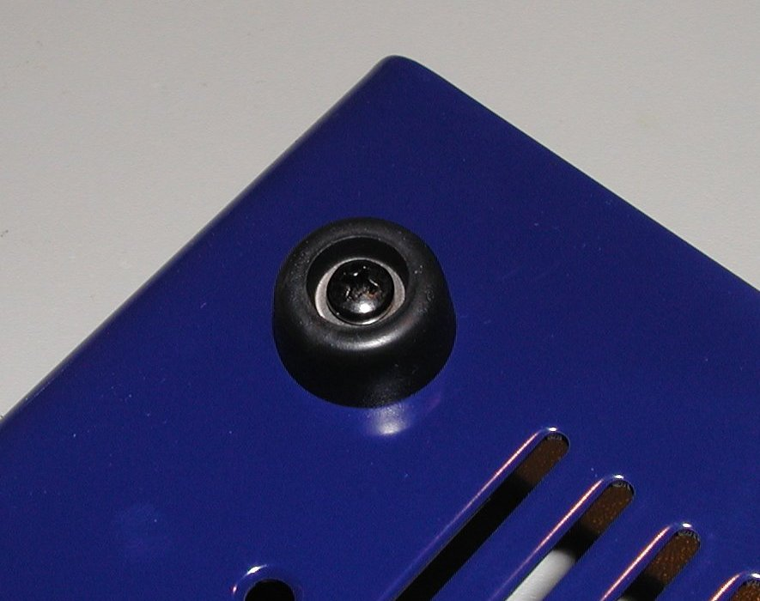Fig. 9: Mounted rubber foot
Remove rear panel from its cardboard box (item 3) and check if it looks as shown on Fig. 10. It should include IEC AC inlet (with AC switch patch cables that is not visible due to blue heatshrink tube), AUX power module with 5-pin AC plug and 3-pin cooling fan receptacle connected, 60 mm cooling fan and Cable set #2 connected.
The IEC AC Inlet has power switch and place for fuse drawer that carry two fuses. Fuse drawer is packed separately (item A4) and supplied two fuses (item E2, see Fig. 13) should be in accordance with AC mains voltage in your country (4 A for 230 Vac or 8 A for 115 Vac).

Do not insert fuse drawer with or without fuses before everything else is assembled.

If you didn’t notice any issues with rear panel parts you can proceed with mounting it to the previously prepared bottom plate by using three bolts from A7 and fix it into positions shown on Fig. 11.

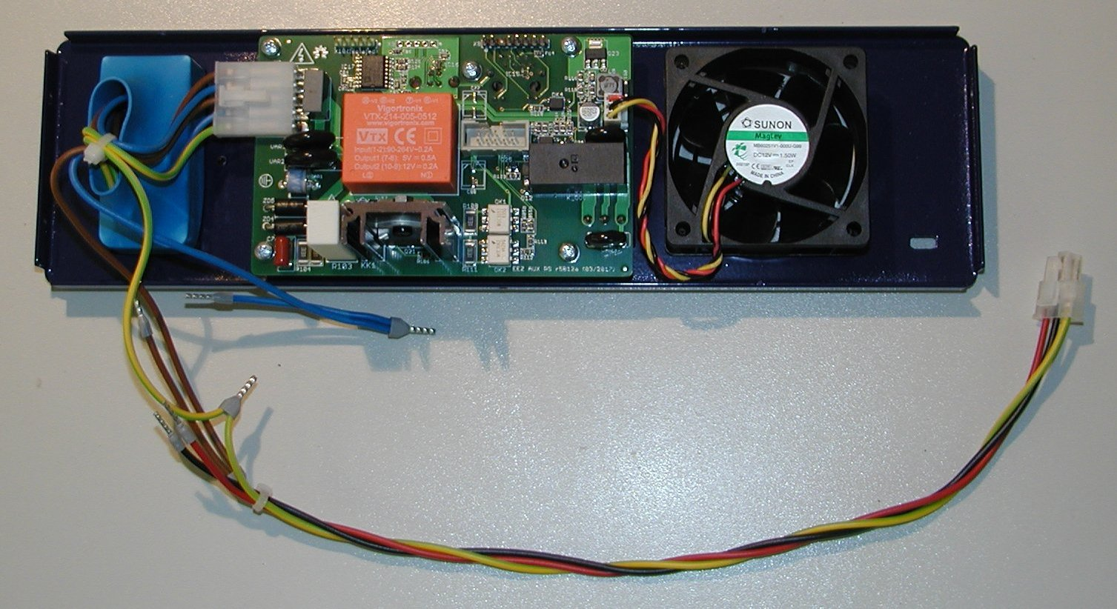Fig. 10: Rear panel assembled
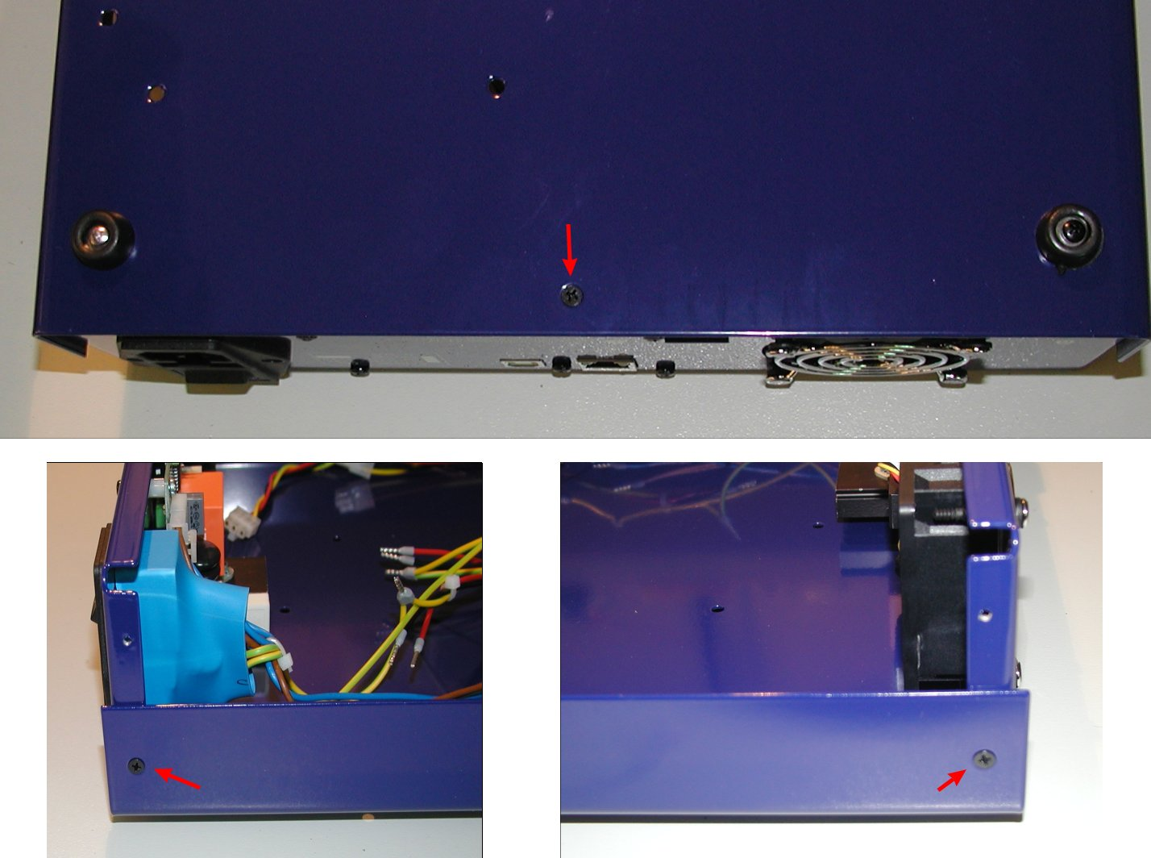Fig. 11: Rear panel mounting positions
Finally you can attach cables A1, A2 and A11 to the AUX power module as shown on Fig. 12.

AC/DC modules
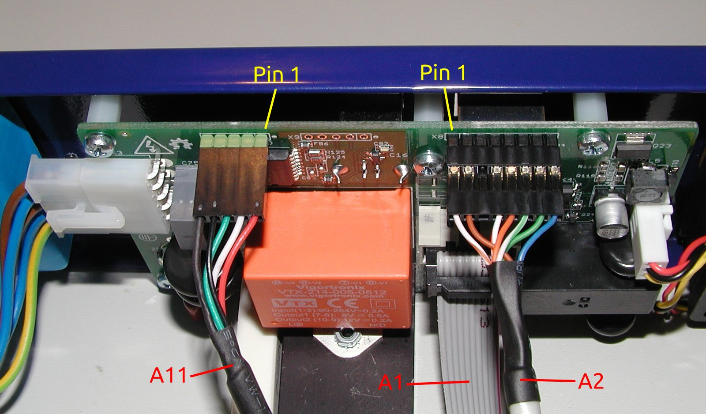Fig. 12: AUX power module wiring
Unpack box with AC/DC modules (item 5) and check if it contains items shown on Fig. 13.

Before proceed with assembly be sure that AC input voltage selection switch (Fig. 14) is properly set. This is especially important if your AC mains voltage is 230 Vac because if switch is set to 115 Vac it is possible that applied mains damage AC/DC module permanently (don’t count with blown fuses here!).
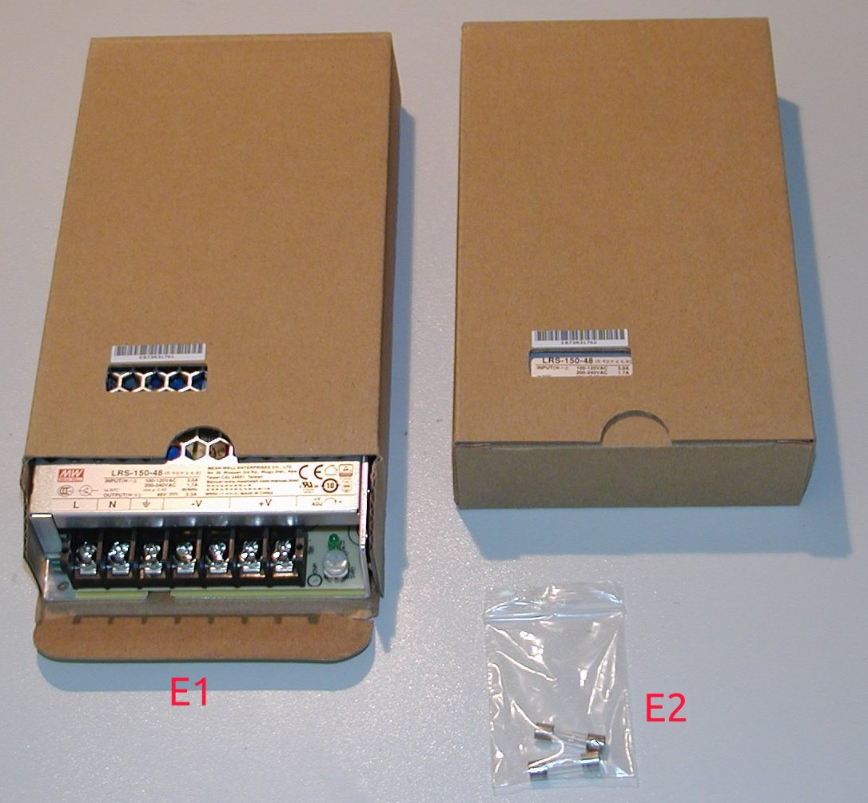Fig. 13: AC/DC modules with fuses

Put aside for the moment E2 and take one of E1 to connect on them Cable set #2 wires as follows:
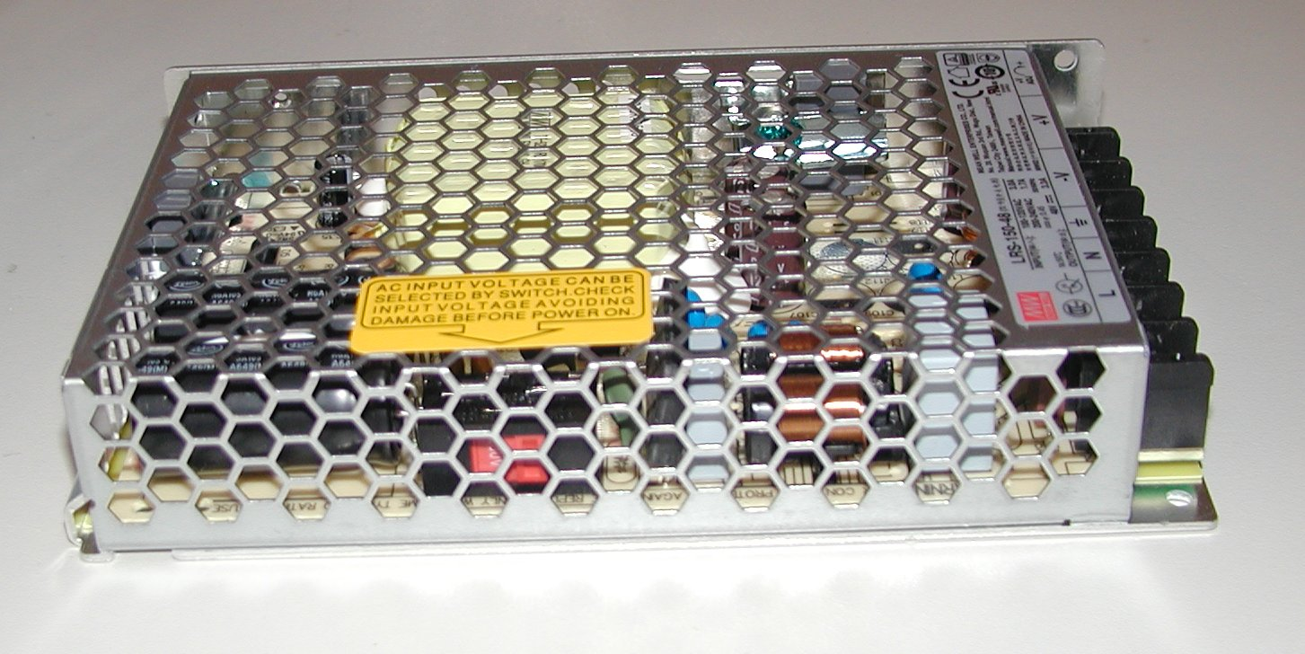Fig. 14: AC voltage selection switch set to 230 Vac

Name | Position | Color
AC line input | L | Brown
AC neutral input | N | Blue
Protective earth | (Earth sign) | Yellow-green
DC output negative | -V | Black
DC output positive | +V | Red

Take also protective earth wire from Cable set #1 (item A10) and mount it on the same position as protective earth from Cable set #2 (see red cycle on Fig. 15).

When first (lower) AC/DC module wiring is completed you can proceed with fix it to the final place on the bottom plate by using two M3 bolts with black countersunk head (from B1) and metal spacers (B2).
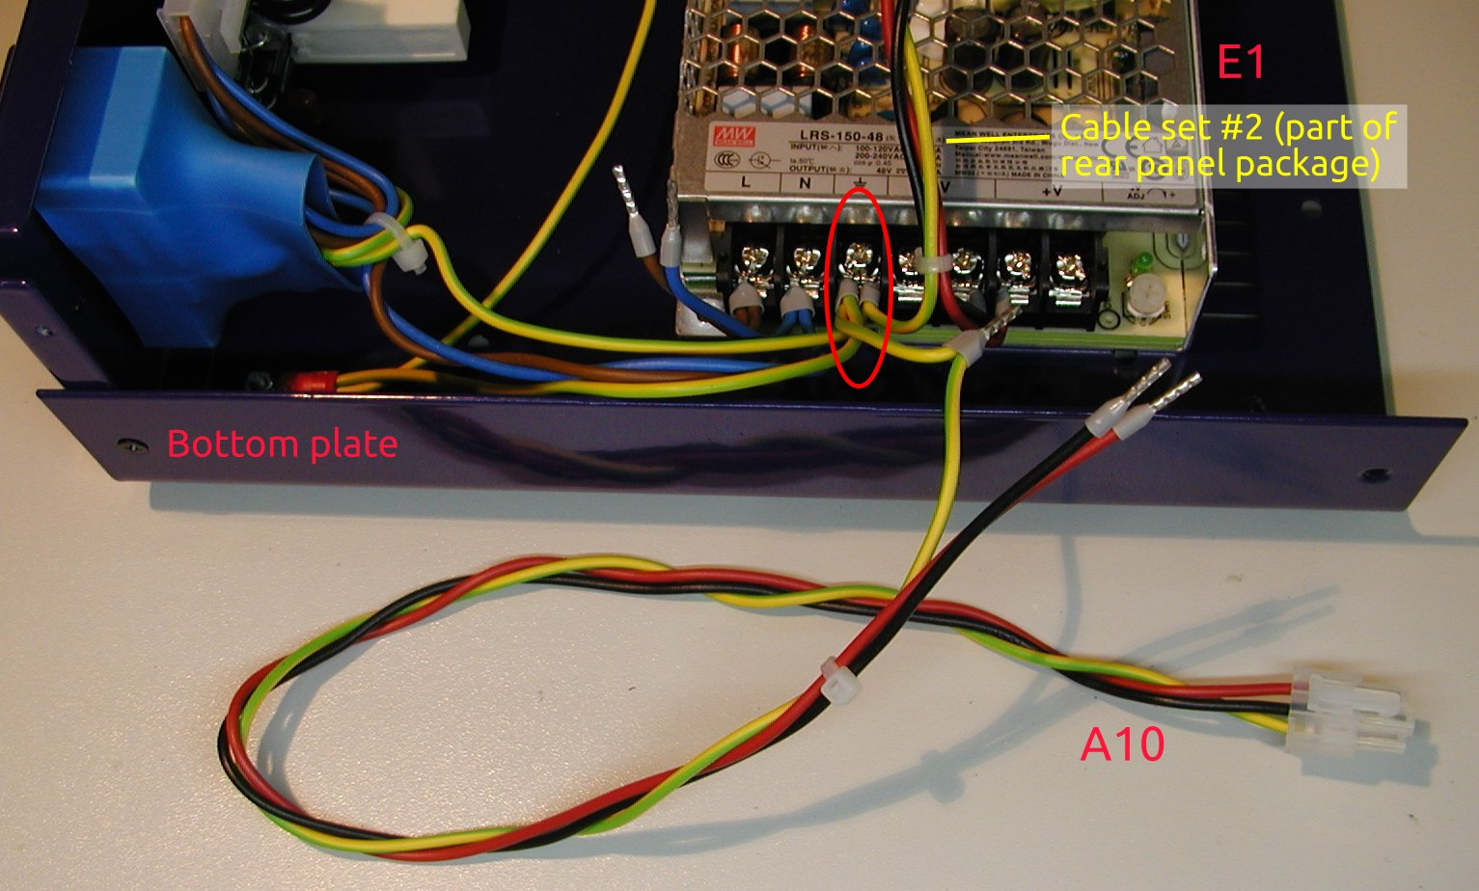Fig. 15: First (lower) AC/DC module wiring

Next step will be attaching AC/DC mounting rail (B3) with M3 bolts (from B1) to the AC/DC module and bottom plate as shown on Fig. 17. AC/DC module has three M3 holes on the side, only two bolts for mounting (red encircled), and another two with black countersunk head (also from B1) for fixing it at the bottom plate (see yellow arrows and Fig. 5).
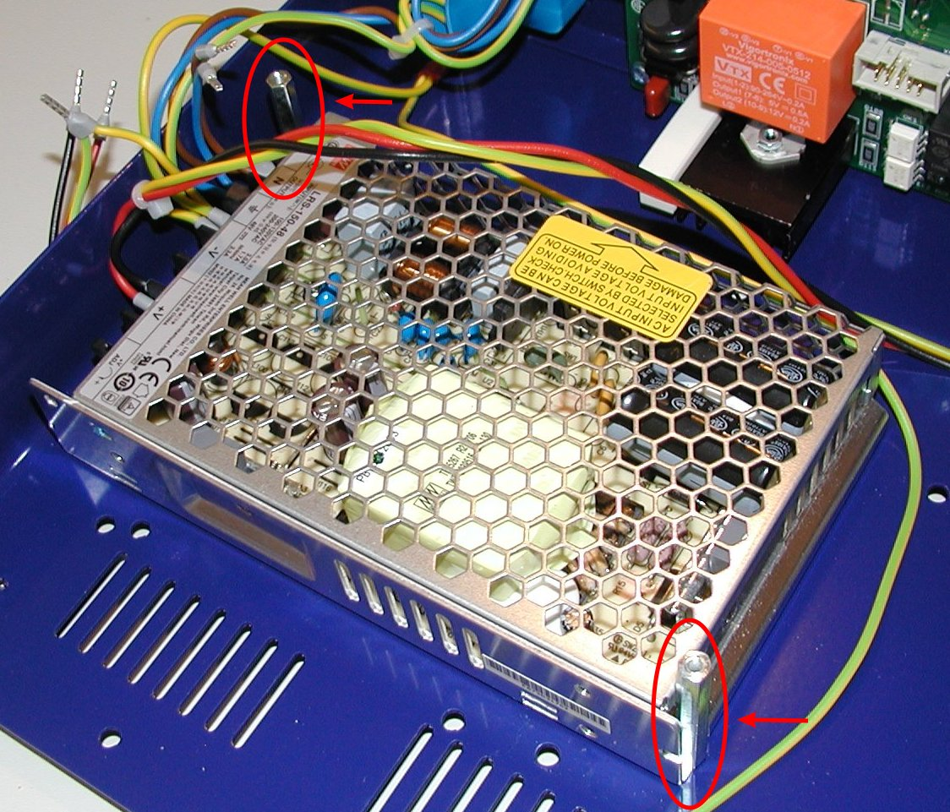Fig. 16: First (lower) AC/DC module fixing with metal spacers

Second AC/DC module can be now installed on top of the first (lower) one. First connect remaining wires from A10 and Cable set #2 as shown on Fig 19.
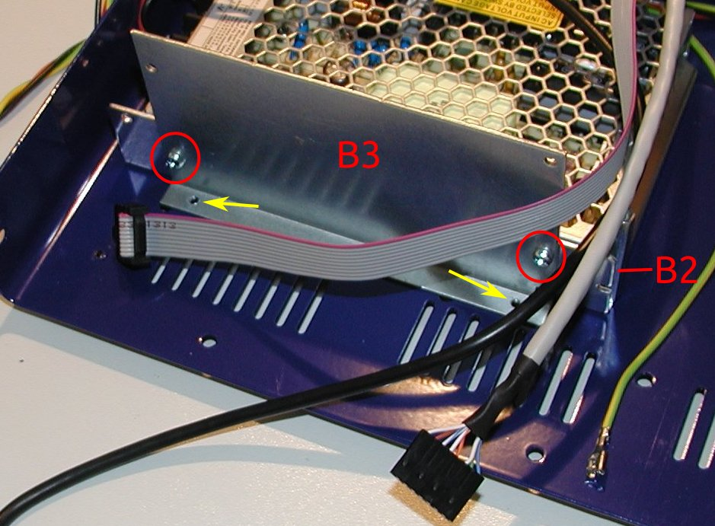Fig. 17: AC/DC modules mounting rail with first (lower) module
Before proceed with fixing second AC/DC module to mounting rail (B3), you can insert all cables that goes to Arduino Shield mounted on the front panel (see red encircled hole on Fig. 18 made by B3, two E1 and B2). You can use one of cable tie (A9) for that (spare another one for AUX temperature sensor A3).

Use two M3 bolts from B1 for fix second (upper) AC/DC module on the side. Use another M3 bolt for fix it only on the spacer B2 that is visible on Fig. 17. Fixing on the next spacer will be performed in the next step.
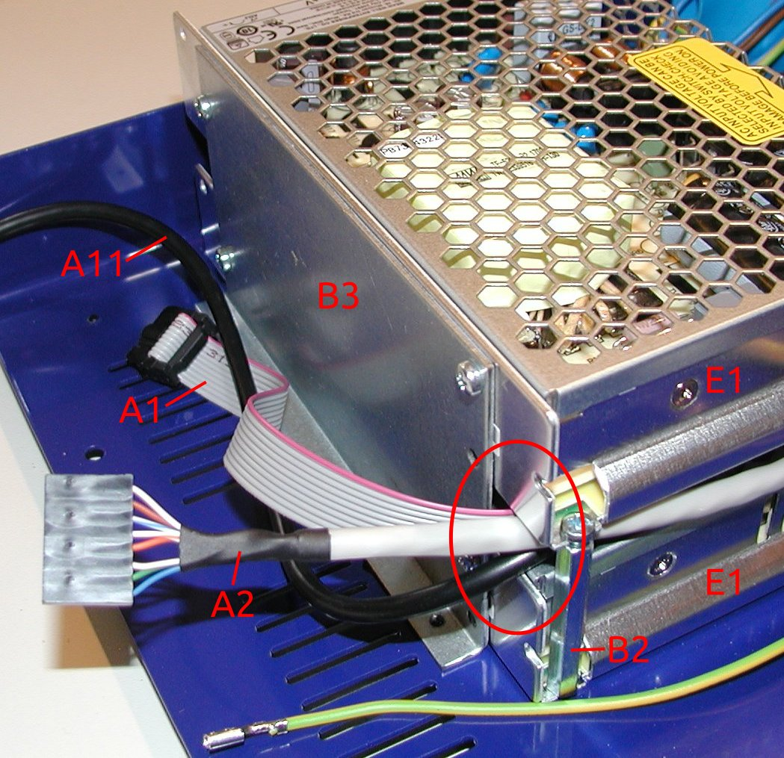Fig. 18: Second (upper) AC/DC module with Arduino Shield wiring

Final step in AC/DC modules mounting is to put a cover (item A6) over second (upper) AC/DC module terminals as an additional safety measure against electric shock when you decide for any reason to operate the PSU with top plate removed. Use two remaining M3 bolts (from B1) and fix it on the places marked with red arrows on Fig. 20.
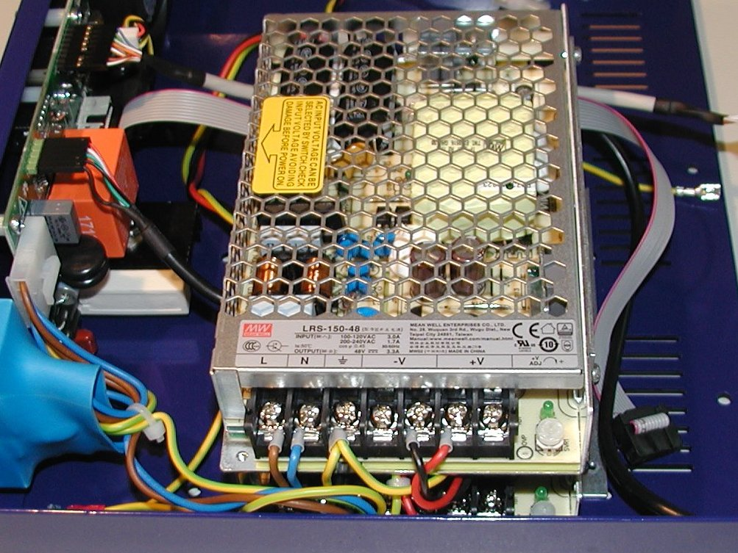Fig. 19: Second (upper) AC/DC module mounting

Front panel
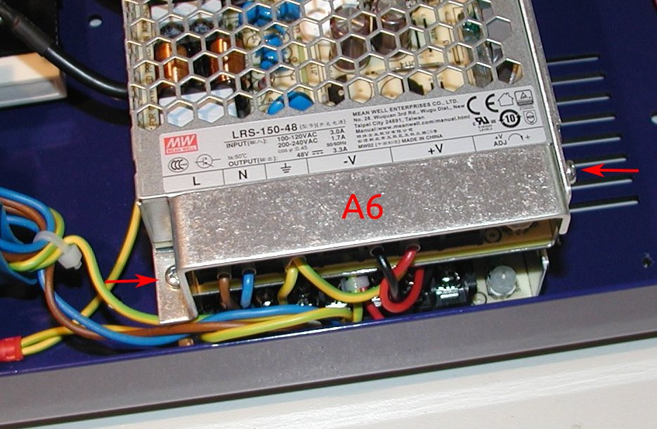Fig. 20: Second (upper) AC/DC module terminal cover
The front panel box content is shown on Fig. 21 that is enclosure’s front panel with mounted Arduino Shield with Arduino Due board, 3.2” TFT touchscreen color display and 4 mm binding posts for power outputs and protective earth.

A first step for the front panel assembly is mounting of handles (item C2). Use two M4 bolts (C1) to fix it on the front panel’s ends. Fig. 22 shows how front panel looks like with handles mounted.
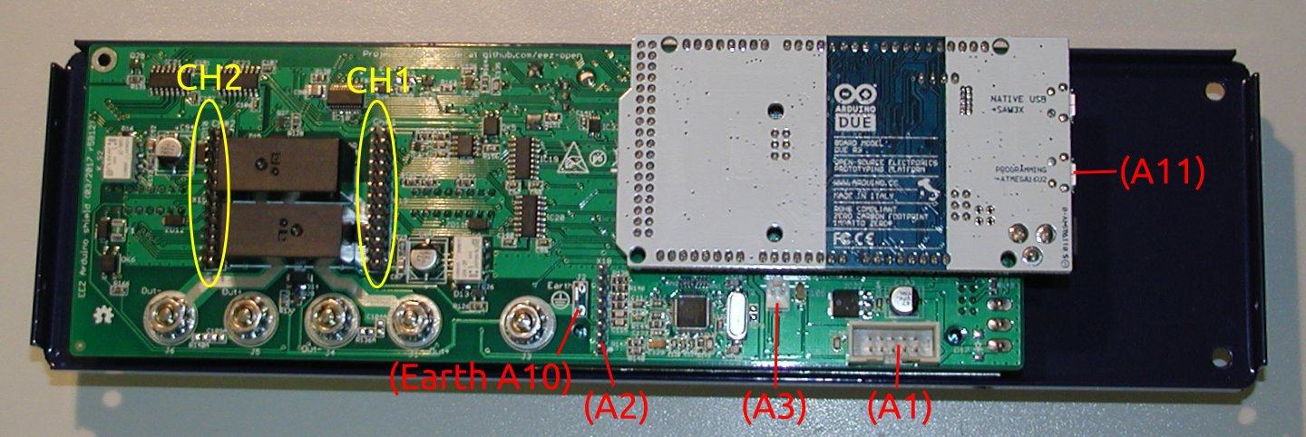Fig. 21: Front panel (back view)

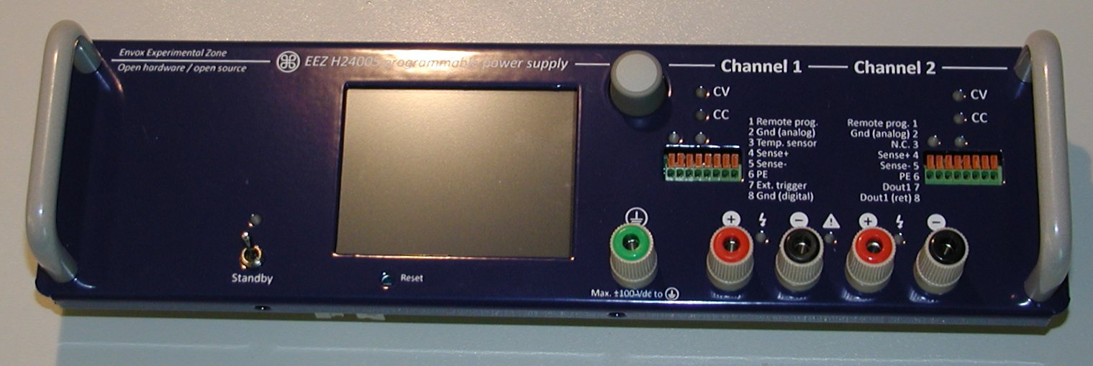Fig. 22: Front panel handles mounted
A next step should be wiring of the Arduino Shield (use red colored text on Fig. 21 as reference). That also include AUX temperature sensor (item A3). Take a special care when inserting USB cable (A11) to the programming port (lower one) on the Arduino Due to not damage micro USB socket. It’s recommended to bend USB cable appropriately before insertion to lower its pressure when it is put into place (Fig. 24).
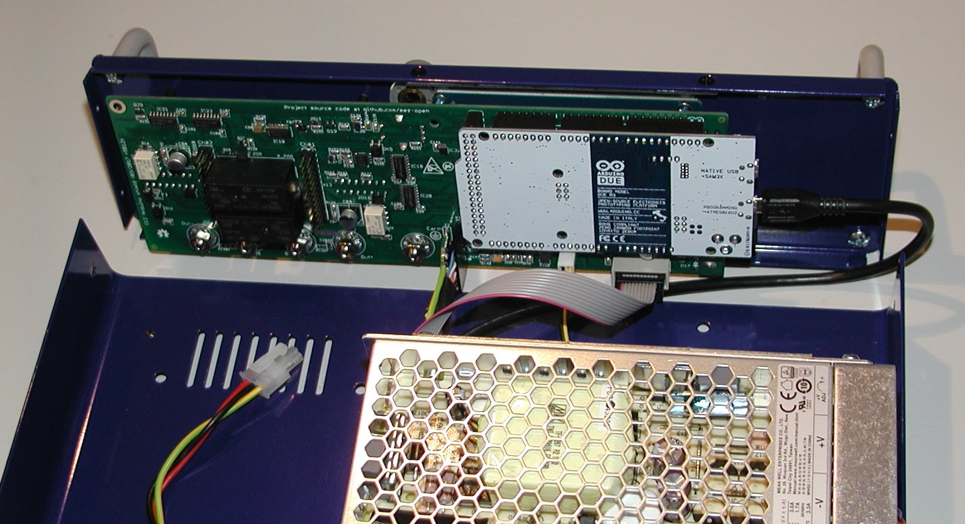Fig. 23: Arduino Shield with cables connected

Use four M3 bolts (from A7) to join front panel with bottom plate following the holes marked on Fig. 5 and Fig. 25
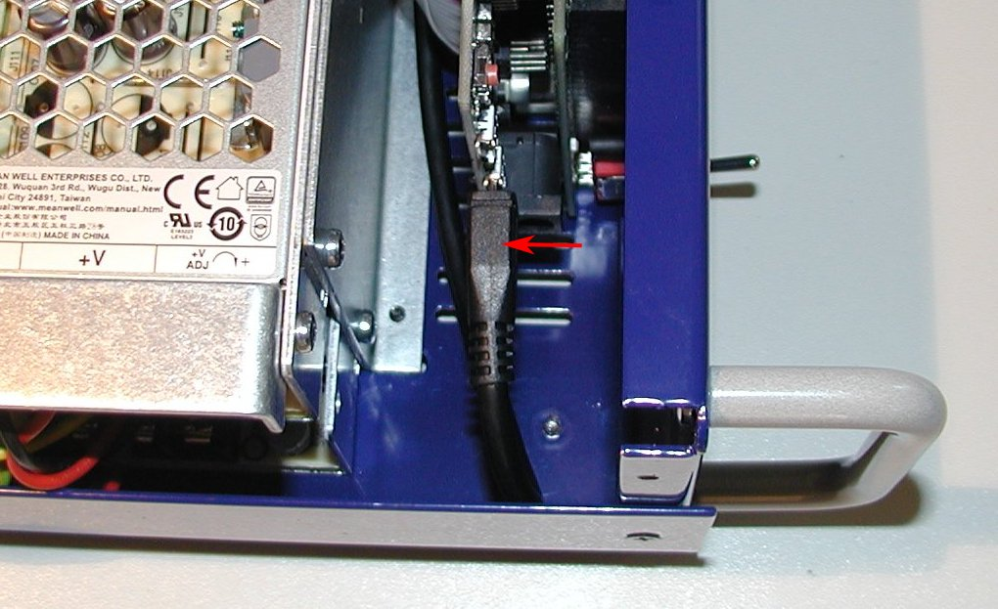Fig. 24: USB cable attached to Arduino Due programming port

When front panel is mounted to the bottom plate it’s possible to fix AUX temperature sensor (A3) someplace above AC/DC modules as shown on Fig. 26. Use one cable tie (A9) for that.
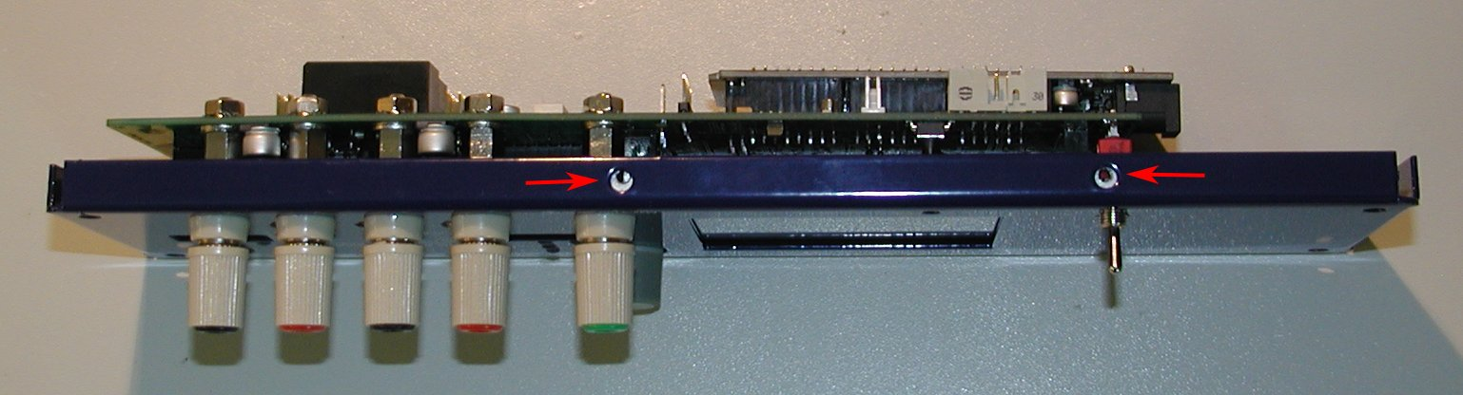Fig. 25: Front panel bottom mounting positions

Power boards
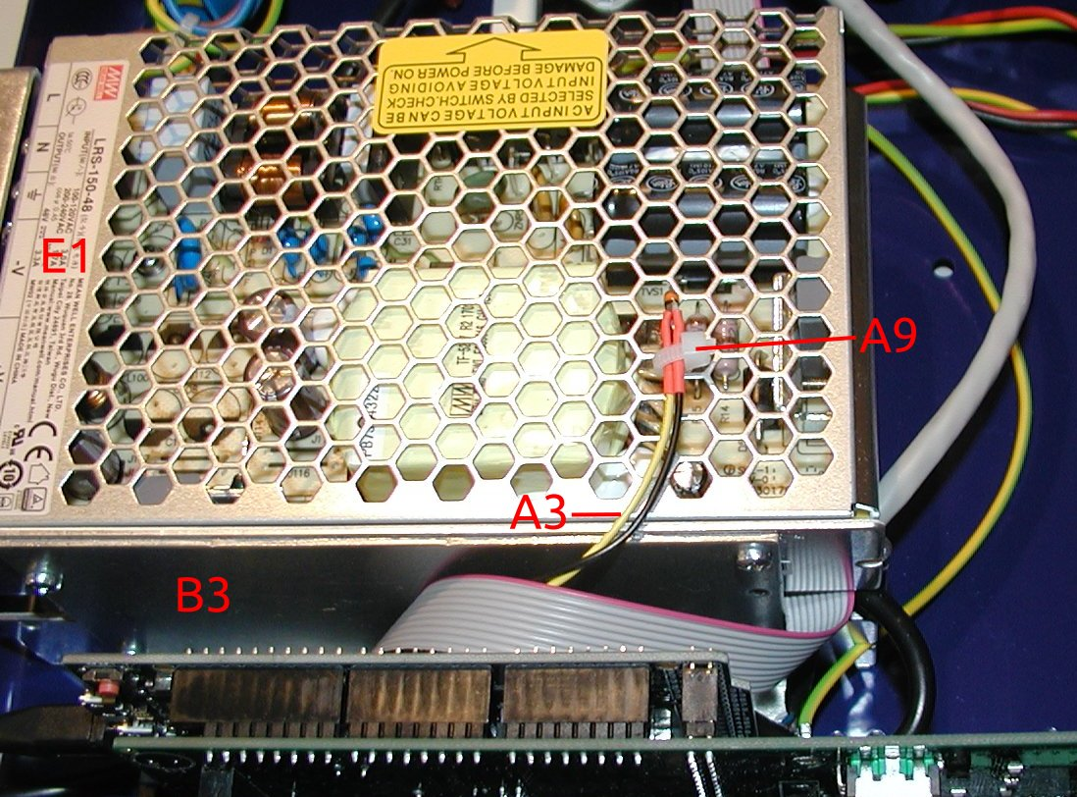Fig. 26: Aux temperature sensor
The Power boards cardboard box contains two Power boards (F1) and M3 bolts (F2) used for mounting. Before mounting power boards to the bottom plate (check Fig. 5) plug in the DC power cable (+48 V) to the DC input connector (red encircled on Fig. 28).

Now you can carefully insert it into Arduino Shield (Fig. 20) that PCB components side is facing toward cooling fan center as shown on Fig. 29. Double check that no misalignment between 26-pin header on the Arduino Shield and Power board’s receptacle (yellow encircled on Fig. 27) exists.

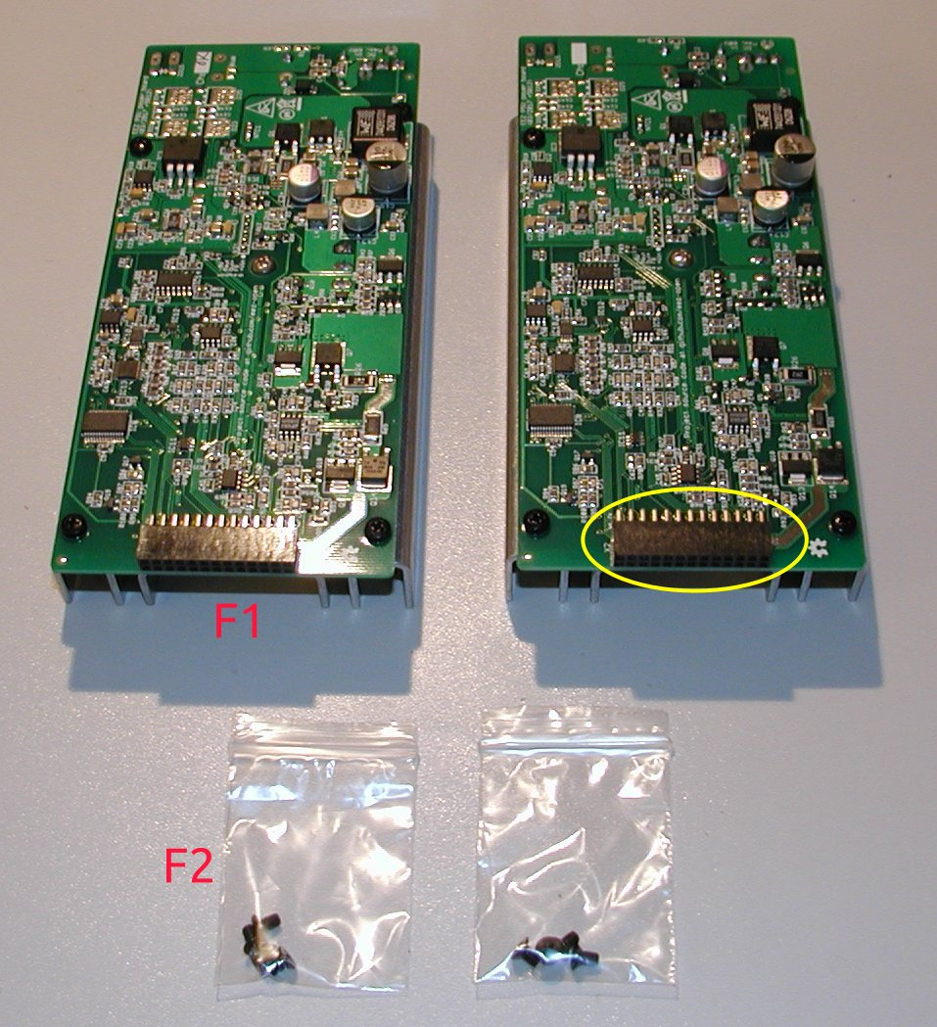Fig. 27: Power boards unpackaged

Final steps
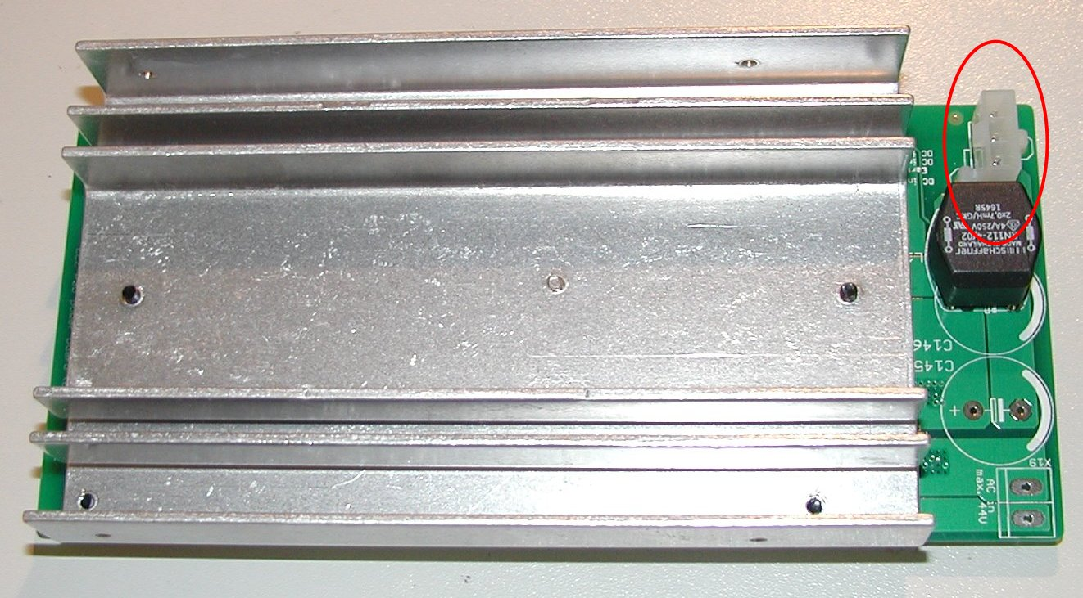Fig. 28: Power board DC input connector
The PSU with all parts mounted is shown on Fig. 29. Covering it with top plate and placing fuses into AC inlet is now only what is left.

You’ll need eight M3 bolts with black countersunk head (from A7 and F2) for mounting top plate.

Check fuses (E2) rating (i.e. 8 A for 115 Vac and 4 A for 230 Vac) before placing them into fuse drawer (A4) as shown on Fig. 30.
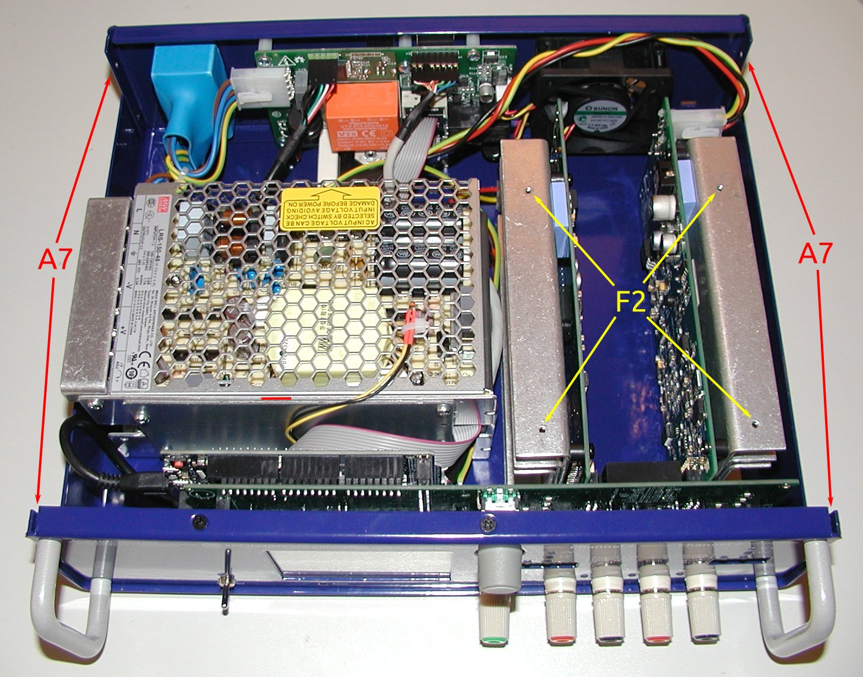Fig. 29: EEZ H24005 assembled without top plate

Mount fuse drawer into IEC AC inlet on the rear panel and insert AC mains power cord (it’s not a part of this kit!) as shown on Fig. 31.
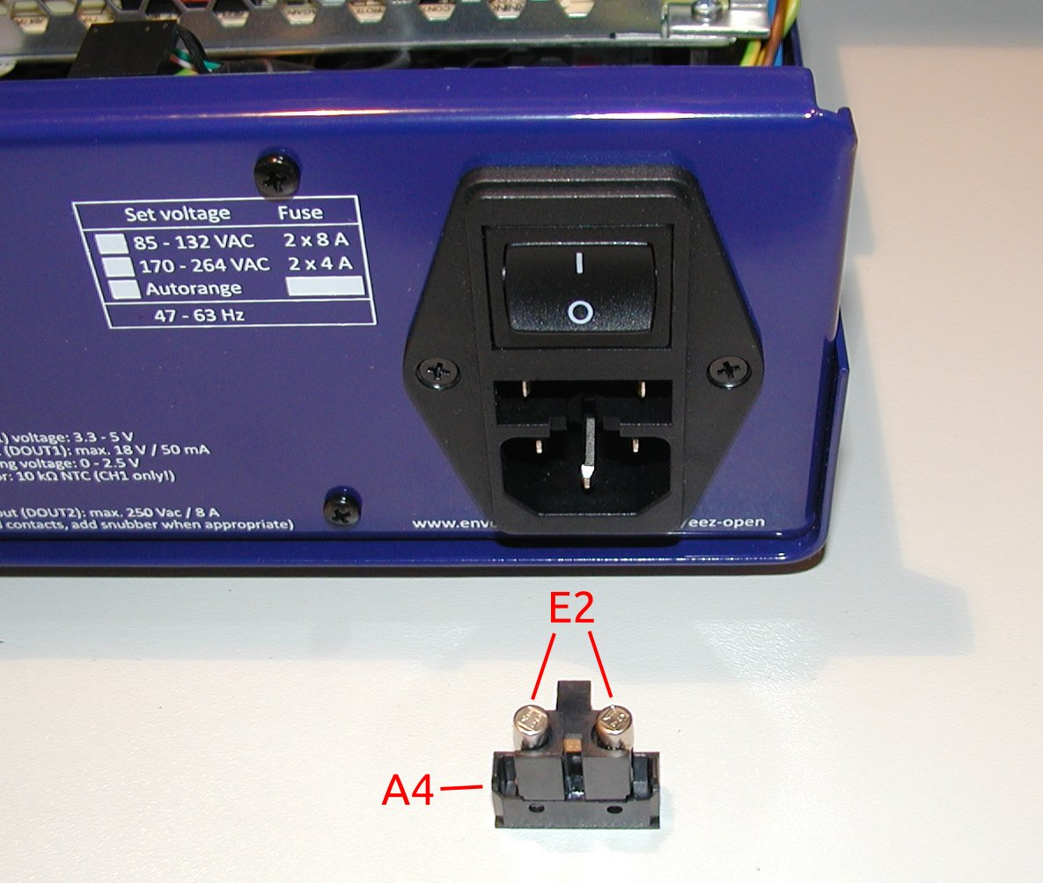Fig. 30: Fuse drawer

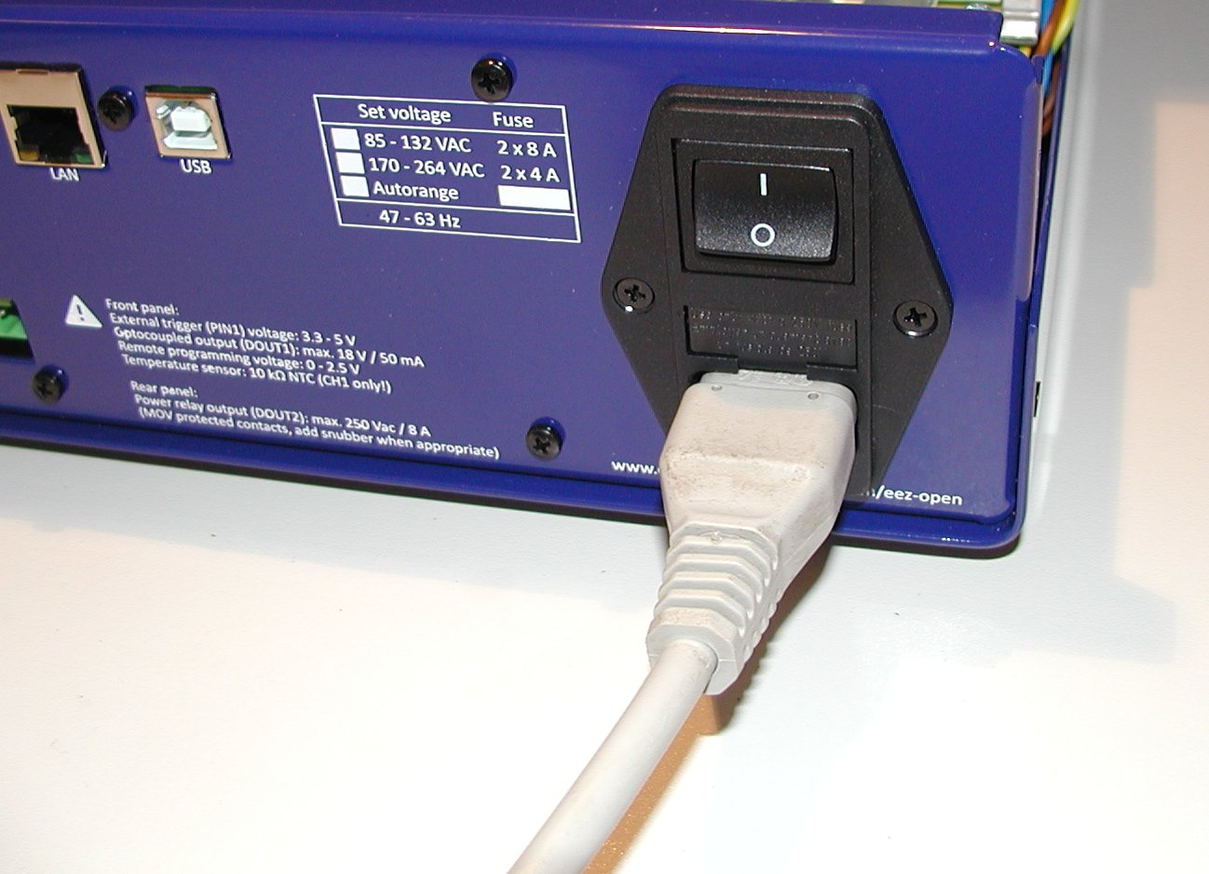Fig. 31: AC inlet with fuse drawer and plugged in power cord
The PSU has on the rear panel a 3-pin connector for Digital out #2 (DOUT2). You can use A8 plug with screw terminals to make connection with external circuits (Fig. 32).

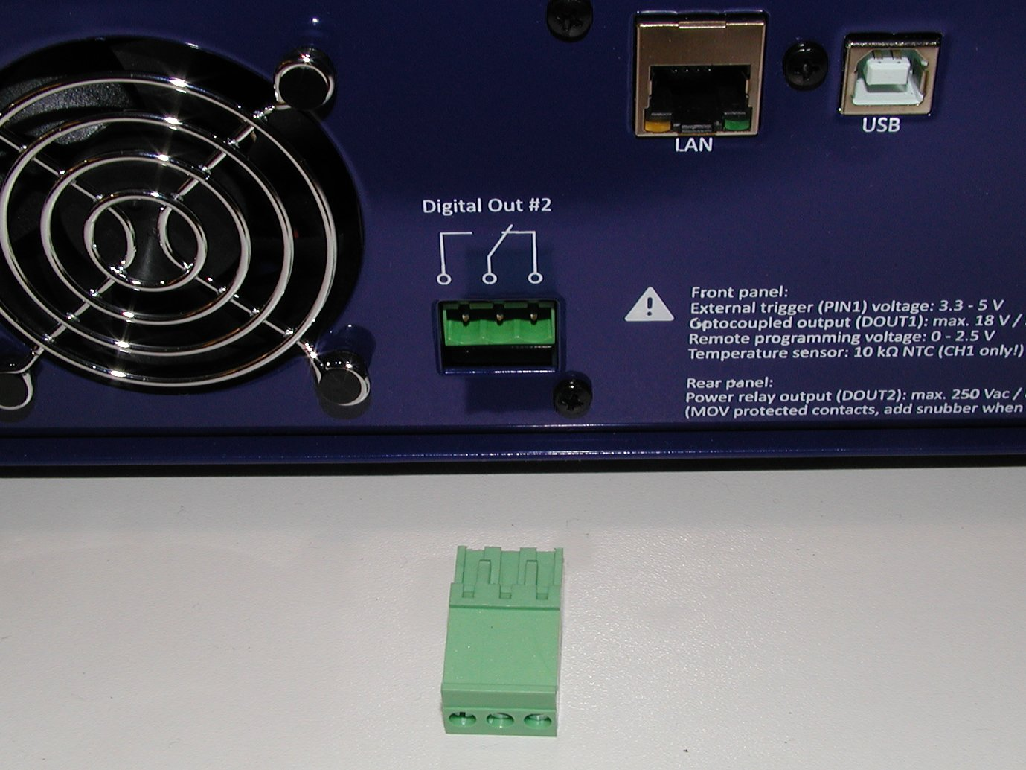Fig. 32: DOUT2 plug-in connector
The PSU complete kit comes with firmware v1.0 loaded into Arduino Due board. For further uploads please follow instructions here. The list of firmware release can be found on the GitHub.

A work in progress

